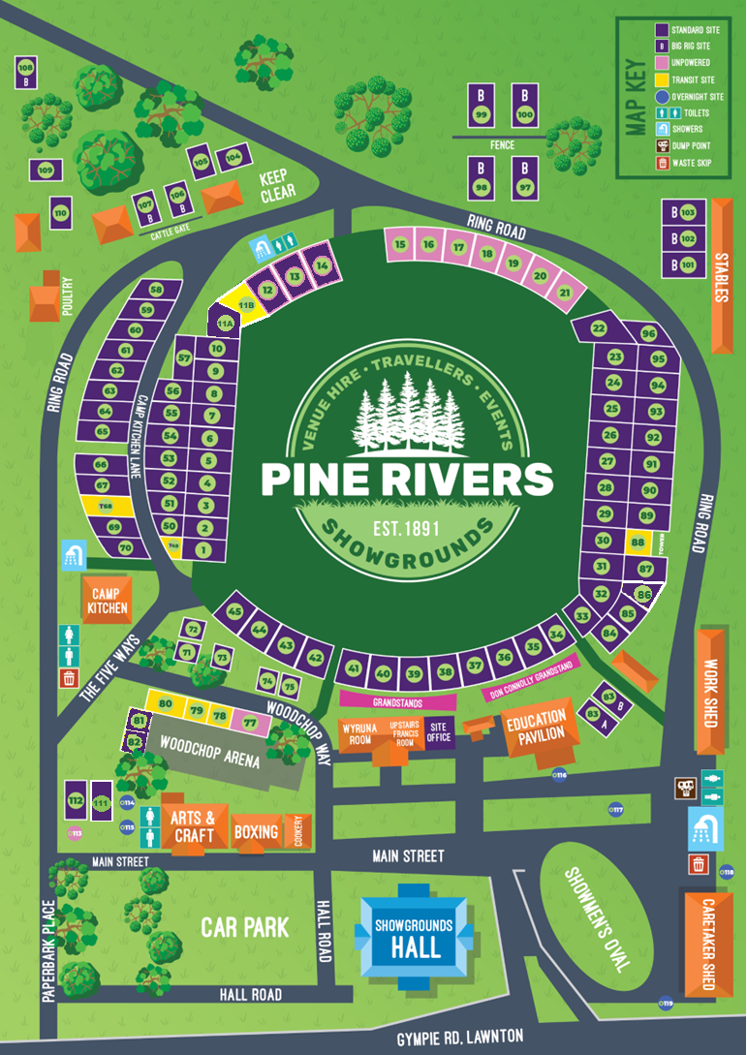
AFTER HOURS - EMERGENCY CONTACT NUMBER - 0447 677 894
OFFICE PHONE – 3205 2597 – Available Mon-Friday 8.30-5pm
PLEASE RESPECT THE Office/Operating hours – Mon-Friday 8.30-5pm,
Saturday 8.30am-3pm and Sunday CLOSED

Follow us on Facebook for events happening on our grounds during your stay
Pine Rivers Showgrounds

Key – Issued key unlocks the following.
Key is required for use of the BBQ in camp kitchen, accessing the shower blocks, and front gate padlock. Gates are locked overnight anytime from 7.30pm to 8.30am. If you go out, TAKE YOUR KEY!
Cash key deposit refunded on check out upon return of the key, if you require an out of hours check out, please arrange this prior during office hours. PLEASE DO NOT LEAVE WITH THE KEY! Lost or damaged keys forfeit your deposit.
Check In  Monday-Friday 12-5pm @ site office.  Saturday- 12-3pm @ Site office.  Sunday – CLOSED | Check Out  Monday-Friday 8.30-11am @ site office.  Saturday-8.30-11am, @ Site office.  Sunday – CLOSED
Check out is by 11:00 am. (Sites still occupied after this time will incur another nights fee). Requests for late check outs must be made before checkout time as we may be at capacity for the day and unable to accommodate a late checkout.
CCTV
Please be aware that surveillance cameras are used within the property.

Vehicles
Vehicles must always stay on the bitumen. Please drive SLOWLY 5kph. Road rules apply within our grounds. All vehicles must park in front of the caravan. NOT BESIDE. No washing of your vehicle or van.

Pets
All pets must be on a lead at all times. Owners must pick up after their pets immediately. Animal waste is to be bagged and dumped in the large skips.

Dump Point
Please keep dump point clean for the next user. No flushing of wipes
Grey Water
Please ensure grey water is not impeding another site, please limit the amount of grey water where possible. No kitchen waste or lint left on ground.
Please move your hose daily.
Your site
Please be considerate of other guests and stay within your allocated site.
NO Mats or Tarps to be placed on the ground, a small step mat is okay.

Damage
Any damage must be reported – fees & charges may be applicable.
Rubbish
Consider the environment where possible. Reduce, Reuse, Recycle. North and south waste skip bins. 10 cent bottle recycle collections. North and south Cardboard please flatten out cardboard.

Facilities
Guests have access to 2 main amenities blocks. Top - Shower/Toilet block and Bottom - Shower/Toilet block. All guests must respect others. Please keep the amenities as you would want to find them.

Camp Kitchen
A multi-use facility for our Guests to enjoy. Please keep noise to a minimum after 10pm. All guests must respect others. Please keep the BBQ and camp kitchen area clean & tidy at all times.

Major events/ Noise
We are a multi-use facility, therefore from time-to-time there is exclusion zones, increased noise, movement and changed road conditions on the grounds. We ask that you respect these zones and engage with the Office if you have any concerns.

These grounds are owned by the Show Society, not Council, and as a consequence we are responsible for the operations, maintenance, infrastructure and upkeep of everything at the grounds. This is achieved by many hardworking Volunteers.
Any breach of the showgrounds rules may result in being asked to leave. Our management staff are legally required to inform the Pine Rivers AH&I Executives in the event of a breach of these regulations.
Thank you for understanding that our team want all guests to have a safe, relaxing, and enjoyable experience. Please help us keep our grounds in the pristine condition you found it.

